**Capstone Project - The Battle of Neighbourhoods**

**WEEK 1**

**Q1. A description of the problem and a discussion of the background.**

***Introduction:***

New York City (NYC), the symbol of American prosperity and liberty, is the USA’s largest and diverse metropolis. Being a city with a long history of international immigration, it is ethnically diverse.

NYC’s population was 8.5 million in 2014, accounting for over 40% of the population of New York State. It is a part of the New York metropolitan area, occupied by appx. 23.6 million people. Over the last decade, NYC has seen a faster growth faster than the region.

This region remains the gateway for legal immigrants into the US, and so is NYC. The term "melting pot" was coined to describe densely populated immigrant neighbourhoods on the Lower East Side. As many as 800 languages are spoken in New York, making it the most linguistically diverse city in the world. English remains the most widely spoken language, although there are areas in the outer boroughs in which up to 25% of people speak English as an alternate language, and/or have limited or no English language fluency. English is least spoken in neighbourhoods such as Flushing, Sunset Park, and Corona.

This diverse culture has also brought in diverse food items. There are many restaurants in New York City, each belonging to different categories like Chinese, Indian, and French etc.

Problem statement:

To find the answers to the following points:

1) Enlist & represent all major parts of NYC that has great Indian restaurants.

2) Identify best location in NYC for Indian Cuisine

3) Find areas for a potential Indian Restaurant

4) Find all areas where no Indian Restaurant are operating

5) Identify best area if you want Indian Cuisine

**Q.2 Description of the data and how it will be used to solve the problem.**

New York City’s demographics show that it is a large and ethnically diverse metropolis. With its diverse culture, comes diverse food items. There are many restaurants in New York City, each belonging to different categories like Chinese, Indian, and French etc.

**For this project we need the following data-**

1. Data that contains list Boroughs, Neighbourhoods along with the latitude and longitude.

2. Data source: https://cocl.us/new_york_dataset

3. Description: This data set contains the required information. And we will use this data set to explore various neighbourhoods of NYC.

4. Indian restaurants in each neighbourhood of NYC.

**Two data sources are used for this-**

1. Data source: Foursquare API

Explanation: By using this API we will get all the venues in each neighbourhood. We can filter these venues to get only Indian restaurants.

1. GeoSpace data

Source: https://data.cityofnewyork.us/City-Government/BoroughBoundaries/tqmj-j8zm

Description: By using this data we will get the New York Borough boundaries that will help us visualize choropleth map.

**WEEK 2**

**Q.3 Methodology section**

1. Collect the NYC data from the following link "[https://cocl.us/new_york_dataset"](https://cocl.us/new_york_dataset%22)
2. 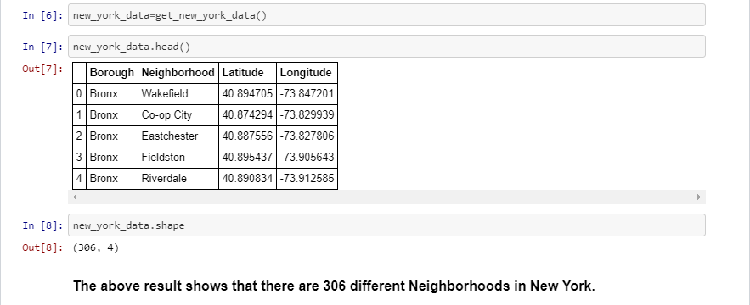Find all venues for each neighbourhood using Foursquare API

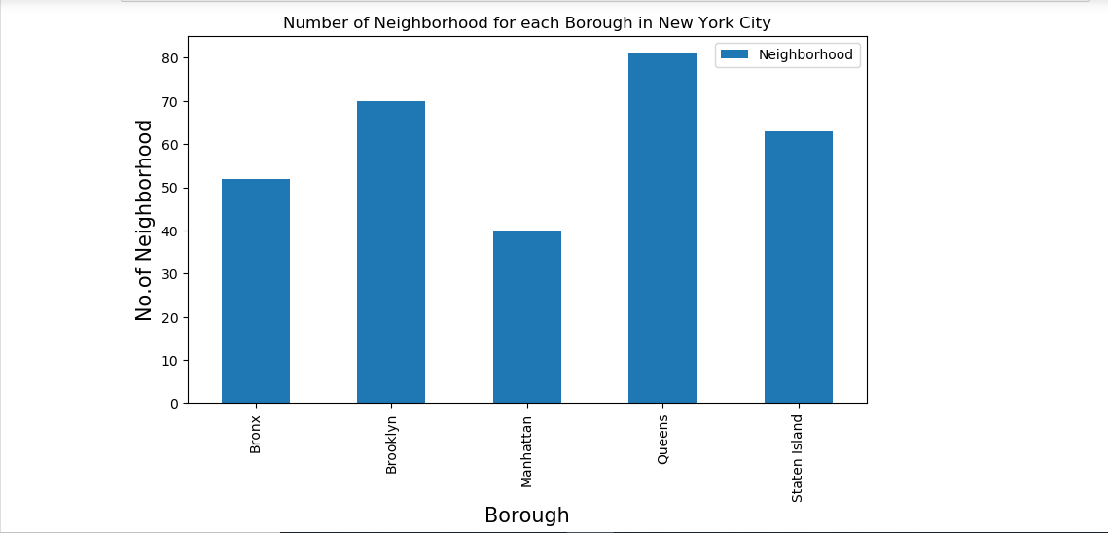

1. 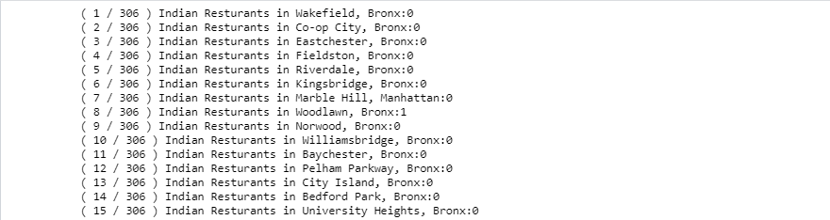Filter out all venues with Indian restaurant for further analysis.

1. Using Foursquare API, find the Ratings, Tips, and Number of Likes for all the Indian Restaurants.

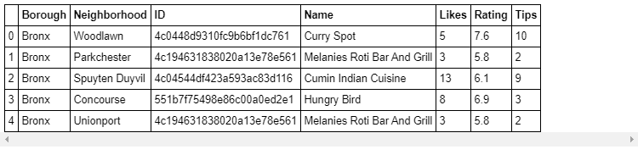

1. Sort Neighbourhoods and Borough the data keeping Ratings as the constraint.

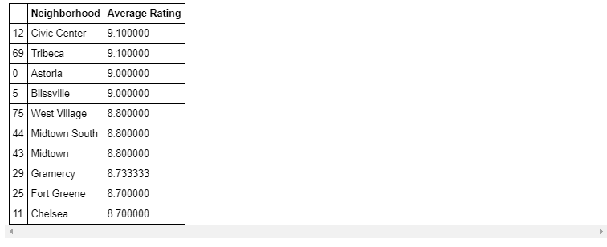

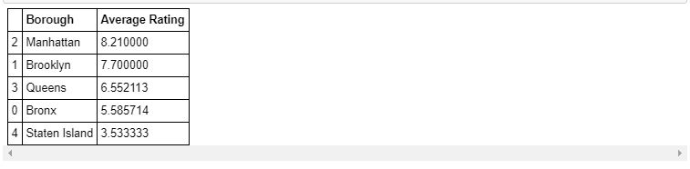

1. Consider all the neighbourhoods with average rating greater or equal 9.0 to visualize on map.

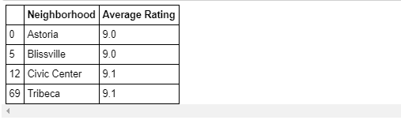

1. Join this dataset to original New York data to get longitude and latitude.

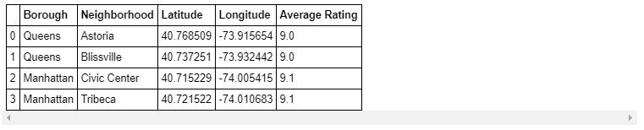

1. Visualize the Neighbourhoods and Borough based on average Rating using python’s Folium library.

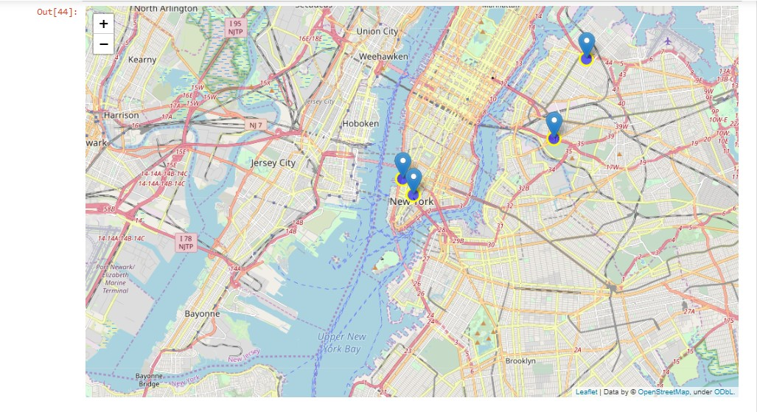**Neighbourhoods** based on average rating:

**Borough** based on average rating:

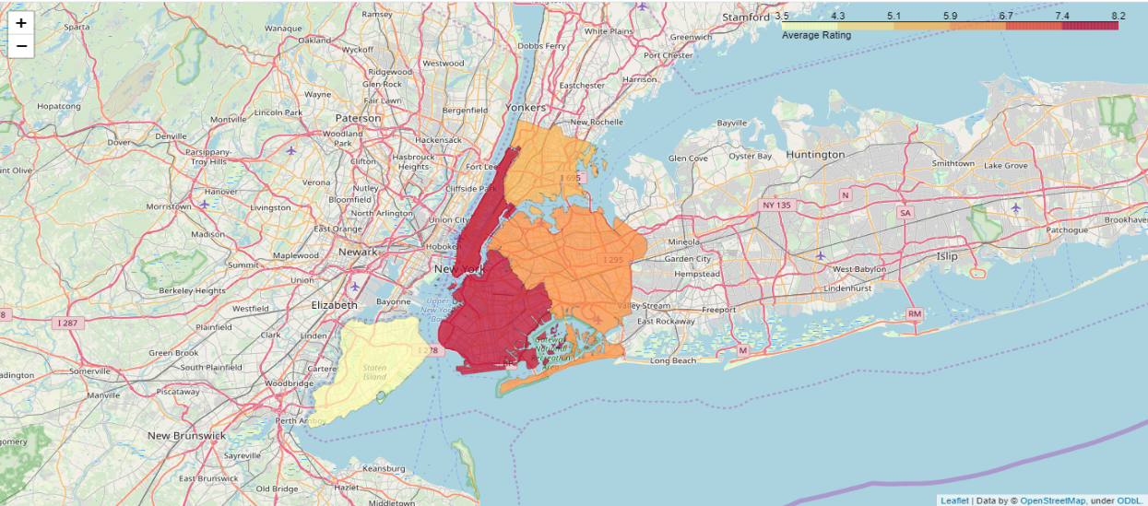

**Q.4 Results section**

1. The following location in New York City has great Indian restaurants.



#### **Astoria** (Queens), **Blissville** (Queens), **Civic** **Center** (Manhattan) are some of the best neighbourhoods for Indian cuisine.

#### **Manhattan** have potential Indian Restaurant Market.

#### **Staten** **Island** ranks last in average rating of Indian Restaurants.

#### **Manhattan** is the best place to stay if you prefer Indian Cuisine.

**Q.5 Conclusion section**

It is feasible to open Indian restaurants in abovementioned neighbourhoods of NYC. This is supported by above analysis of data.

**\*\*\*\*\***